**Portfolio Optimization**

**Anna Chhean**

**Problem Statement**

Investing is complex, especially for individuals lacking the expertise or time to navigate financial markets. Traditional wealth management often presents too many choices, making it difficult for individuals to determine the best strategy for long-term financial security. This complexity causes confusion, leading many to miss optimal returns. A simplified, structured investment strategy could help individuals achieve their financial goals while reducing the burden of decision-making.

Given a modest Porfilio of $250,000, the team needs to allocate funds within three key asset classes:

The portfolio consists of five asset classes, each with distinct risk-return profiles:

1. **Equities (SPY, QQQ, VTI)** – High return potential with significant volatility.
2. **Fixed Income (BND - Bonds)** – Offers stability and lower returns.
3. **Commodities (GLD - Gold)** – Serves as an inflation hedge but is cyclical.

The goal is to determine the optimal allocation across these asset classes aiming to maximize returns while minimizing risk, adhering to constraints that maintain balance and risk management across different market conditions. The Sharpe Ratio is the primary measure to balance return risk.

### Optimization Constraints:

* Minimum and maximum allocation limits (15% and 35%, respectively) for each asset class ensure diversification.

The total weight of the portfolio must sum to 100%

### Evaluation Methods and Evaluation Measures

We employed an optimization model in Microsoft Excel using linear programming and the Solver tool to determine the optimal course of action for portfolio allocation.

The evaluation methods that we chose are an optimization model in Microsoft Excel using linear programming to determine optimal course of action for an investment portfolio scenario. We chose excel solver for this product because it was the most intuitive solution for our scenario based on our recent MSBA course explorations. Furthermore, it uses a tool that is widely accessible and does not require an expensive subscription like some of Microsoft’s other modeling tools. Additionally, several of our group members had previous experience with financial analytics using this platform.

#### Evaluation Measures:

1. **Expected Return (%)** – The weighted sum of asset returns.
2. **Portfolio Standard Deviation (%)** – A measure of risk calculated using the covariance matrix.
3. **Sharpe Ratio (%)** – The primary measure, calculated as:
$$\frac{Expected Return - Risk Free Rate}{S\tan{d}ard Diviation}$$

4. **Diversification Constraints** – Ensuring no asset exceeds or falls below predefined weight limits (15% – 35%).

### Decision Alternatives for Portfolio Optimization

In this **portfolio optimization model**, the primary decision alternatives involve different **asset allocation strategies** that balance **risk and return**. Based on the given constraints and financial objectives, the final set of decision alternatives considered in the analysis include:

1. **Conservative Portfolio:**
   1. Higher allocation to **Bonds (BND)** for stability and lower risk.
   2. Reduced exposure to **equities (SPY, QQQ, VTI)** to minimize volatility.
   3. Moderate allocation to **Gold (GLD)** as a hedge against inflation.
   4. Objective: **Minimize standard deviation while ensuring reasonable returns.**
2. **Aggressive Growth Portfolio:**
   1. Higher allocation to **Nasdaq (QQQ) and SP500 (SPY)** to maximize returns.
   2. Reduced exposure to **Bonds (BND)**, increasing portfolio risk.
   3. Limited exposure to **Gold (GLD)**, as it may not align with high-growth strategies.
   4. Objective: **Maximize expected return, accepting higher volatility.**
3. **Balanced Portfolio (Moderate Risk):**
   1. **Diversified** allocation across all assets to balance **growth and stability**.
   2. Approximately equal allocation to **SPY, QQQ, VTI**, ensuring exposure to equities.
   3. Moderate allocation to **BND** to control risk.
   4. **Gold (GLD) included** to provide inflation protection.
   5. Objective: **Optimize risk-adjusted return using the Sharpe Ratio.**
4. **Risk-Adjusted Maximum Sharpe Ratio Portfolio (Final Choice):**
   1. Allocation based on **modern portfolio theory (MPT)** to maximize the **Sharpe Ratio**.
   2. Optimal weight distribution among **SPY, QQQ, VTI, BND, and GLD** based on expected return and covariance matrix.
   3. Constraints ensure a minimum of **15% allocation per asset** and a maximum of **35%** to maintain diversification.
   4. Objective: **Achieve the highest return per unit of risk.**

### Final Decision:

The **Risk-Adjusted Maximum Sharpe Ratio Portfolio** was selected as the **optimal strategy**. These alternative balances **return and risk** effectively, ensuring the best possible **risk-adjusted performance** while adhering to diversification constraints.

### Figural Model of Decision Process

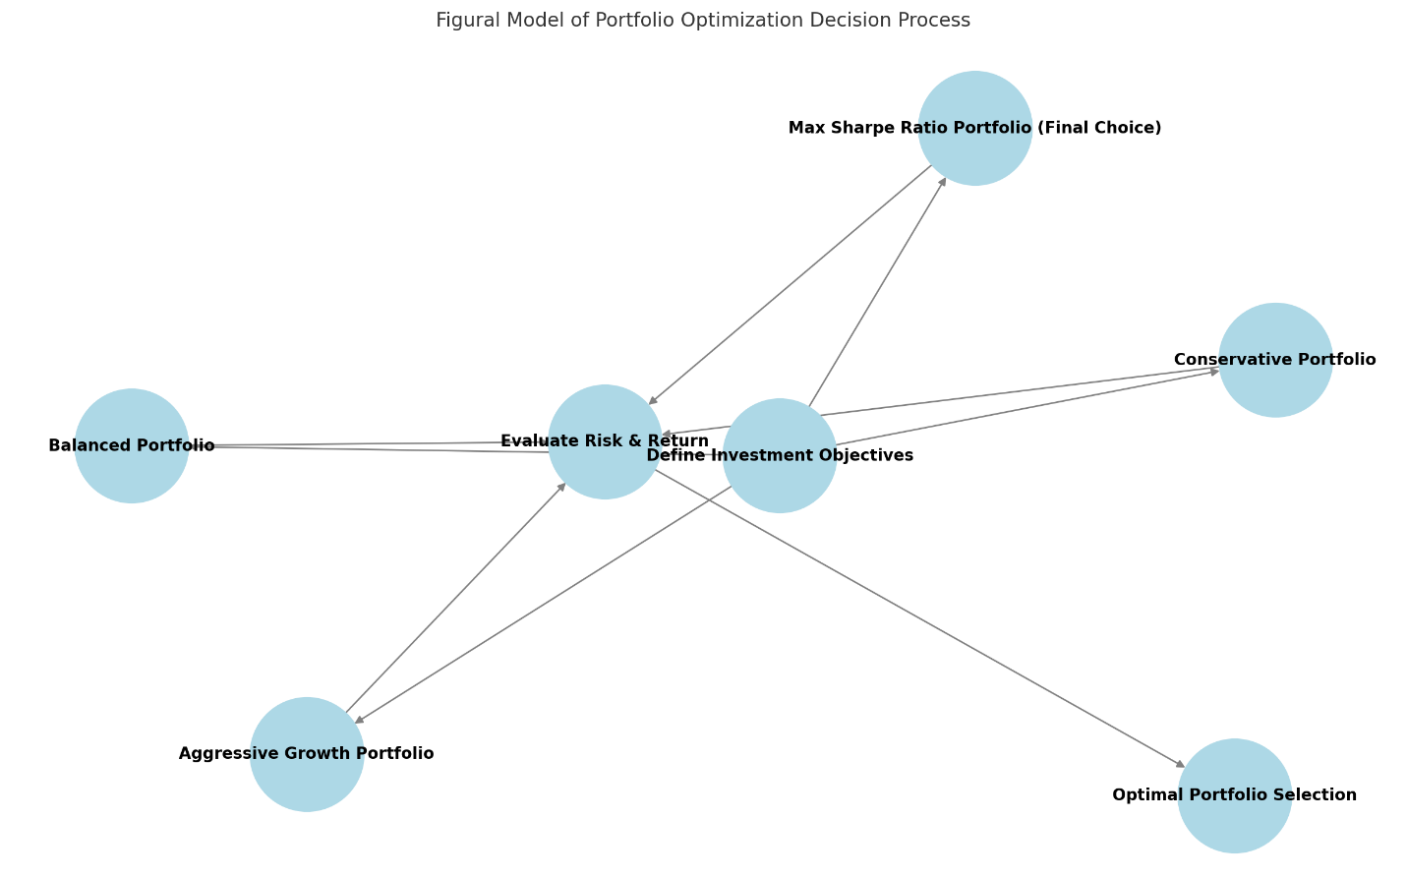

The decision flow follows these key steps:

1. **Define Investment Objectives** – Setting portfolio goals.
2. **Decision Alternatives:**
   1. **Conservative Portfolio**
   2. **Aggressive Growth Portfolio**
   3. **Balanced Portfolio**
   4. **Max Sharpe Ratio Portfolio (Final Choice)**
3. **Evaluate Risk & Return** – Assessing the trade-offs between return and risk.
4. **Optimal Portfolio Selection** – Choosing the best allocation strategy.

### Uncertainty Scenarios

External factors such as changes in economics and market conditions (inflation, interest rates, demand shifts, or competitor action) and regulatory changes will affect the annual return of assets in our portfolio. Using sensitivity analysis, we are looking at how changes in return rate of each asset affect our weight to invest.

**S&P 500 return changes**:

Looking at S&P 500, we set a minimum return to 5% and maximum return to 25% with 2.5% increment. We see that the optimal weight stays constant from 5% - 15% annual return rate, but we see sharp increase in weight after 17.50% annual return rate, then, it remains constant after 35% annual return rate. This makes sense, as the model has constraints of 15% minimum weight, 35% maximum weight. Bond is not sensitive to changes in annual return for S&P 500 as the graph shows flat line, meaning the investment allocations do not change regardless of how S&P 500 returns fluctuate. The same applies to VTI. However, if we look at Nasdaq and Gold, we see a different story. For Nasdaq, weight decreases as S&P return increases. When S&P 500 returns are low, Nasdaq has higher allocation (diversification effect). As S&P return increases, Nasdaq allocation declines, suggesting competition between these asset classes. For Gold, weight increases until 15% S&P returns, then drops. When S&P 500 returns are low, gold allocation increases as a hedge. As S&P returns rise, gold becomes less attractive, reduction its weight.

|  |  |
| --- | --- |
|  | |
|  |  |
|  |  |

**Bond Return Changes:**

Next, we set the minimum return for Bond to 1% and maximum to 15% with 1% increment and observe changes in allocation percentage to each asset. We see that a sharp increase in bond allocation is observed after the bond return rate reaches approximately 7%. This indicates that the optimizer starts favoring bonds once their return crosses a certain threshold, reallocating from other assets. For Gold, the allocation initially increases slightly but drops significantly after 7%, stabilizing at a lower level. This suggests that when bond returns become more attractive, funds shift away from gold. For S&P 500, the allocation remains constant at 15% regardless of changes in the bond return rate. This suggests that SP500 is not affected by variations in bond returns in this model. The same is true for VTI. For Nasdaq allocation, there is a gradual decrease as bond returns rise. Similar to gold, this implies that higher bond returns make Nasdaq investments less favorable.

|  |  |
| --- | --- |
|  | |
|  |  |
|  |  |

**Gold Return Changes:**

When we change the input value in Gold to a minimum of 5% and maximum 25% with increment of 2.5%, the sensitivity analysis shows a significant increase in gold allocation is observed as the gold return rate rises. The allocation jumps from 15% to 35% at around a 10% gold return rate and stabilizes at 35% thereafter (note that our model has minimum weight and maximum weight of 15% 35%, respectively). This indicates that the model favors gold over other assets when its returns improve. S&P 500, Bond, and VTI allocations are unaffected, suggesting they are either fixed components or less sensitive to gold price movements. In Nasdaq allocation, we see a sharp decrease occurs as gold returns increase. The allocation drops from 35% to 15% around the 10% return rate, suggesting a substitution effect where gold replaces Nasdaq as an attractive asset.

|  |  |
| --- | --- |
|  | |
|  |  |
|  |  |

**Nasdaq Return Changes:**

Next, we observed the changes in the allocation percentage of each asset, when we set the minimum value to 5% and maximum to 30% with 2.5% increment in Nasdaq. We see the optimizer shift more weight toward Nasdaq when it offers higher returns, reinforcing its role as a growth asset. Gold allocation initially increases, peaking at 35%, but then declines significantly beyond a certain Nasdaq return rate. This implies that when Nasdaq returns are high, the model reallocates funds away from gold. For S&P 500, it initially decreases from 18% to 15% as Nasdaq returns rise and then remains stable at 15%. This suggests that when Nasdaq returns are lower, SP500 is preferred. However, as Nasdaq becomes more attractive, SP500 is reduced but stabilizes at a fixed allocation. Bonds and VTI remain unchanged, suggesting they are core holdings with stable allocations (insensitive).

|  |  |
| --- | --- |
|  | |
|  |  |
|  |  |

**VTI Return Changes:**

When we set VTI’s return at minimum 5% and maximum 25% with 2.5% increment for sensitivity analysis, we observed that VTI’ s allocation percentage Remains constant at 20%, meaning it plays a predefined fixed role in the portfolio, independent of return fluctuations. When looking at gold allocation, we see that it increases gradually as VTI return rises. This indicates that when VTI’s return improves, the optimizer allocates more funds to gold. On the other hand, Nasdaq allocation decreases gradually as VTI return increases. This suggests that when VTI becomes more attractive, funds are moved away from Nasdaq. S&P500 and Bond allocations remain unchanged, suggesting they are not influenced by VTI’s return.

|  |  |
| --- | --- |
|  | |
|  |  |
|  |  |

### Data Evaluation & Limitations

To build a comprehensive dataset for portfolio optimization, we require:

**Historical Return Data** – To estimate expected returns and standard deviations for different asset classes. We have compiled 10 years of closing prices for each asset class. However, pulling data manually from Yahoo Finance is time consuming, and only it allows us to download a certain number of periods worth of data. So, we wrote a Python script to pull all closing prices all assets' classes in a ten-year period.

**Covariance Matrix Data** – To measure correlations between asset classes and assess portfolio diversification. First, we created another table to calculate the actual return of closing period for each asset (this is from the historical data we collected), then, we created covariance matrix from actual return calculated using data analysis feature in Excel.

**Limitations in Data Collection:**

**Market Volatility Impact** – Historical data may not fully reflect future market behavior, requiring assumptions that introduce bias.

**Macroeconomic Factors** – External factors such as interest rate changes and inflation can shift asset performance, making long-term predictions uncertain.

**Conclusion**

The Risk-Adjusted Maximum Sharpe Ratio Portfolio was selected as the best strategy for optimizing risk-adjusted returns. Through sensitivity analysis, we demonstrated how portfolio allocation shifts in response to changing market conditions, ensuring adaptability under uncertainty. While our model is effective, limitations in historical data availability and macroeconomic unpredictability highlight the need for continuous monitoring and adjustment of portfolio strategies.

Next Steps: Future improvements could incorporate machine learning-based predictive models to enhance asset allocation decision-making dynamically.